Dear Boys and Girls,
Your kindness was noticed all the way at North Pole Academy. Congratulations on making it to the Top of the Nice List!
We worked together to make this Christmas Eve surprise just for you. Inside are cozy pajamas, a storybook, and a little treat to enjoy while you wait.
We hope our surprise brings you good Christmas dreams.
Merry Christmas!
With love,
The Dream Team
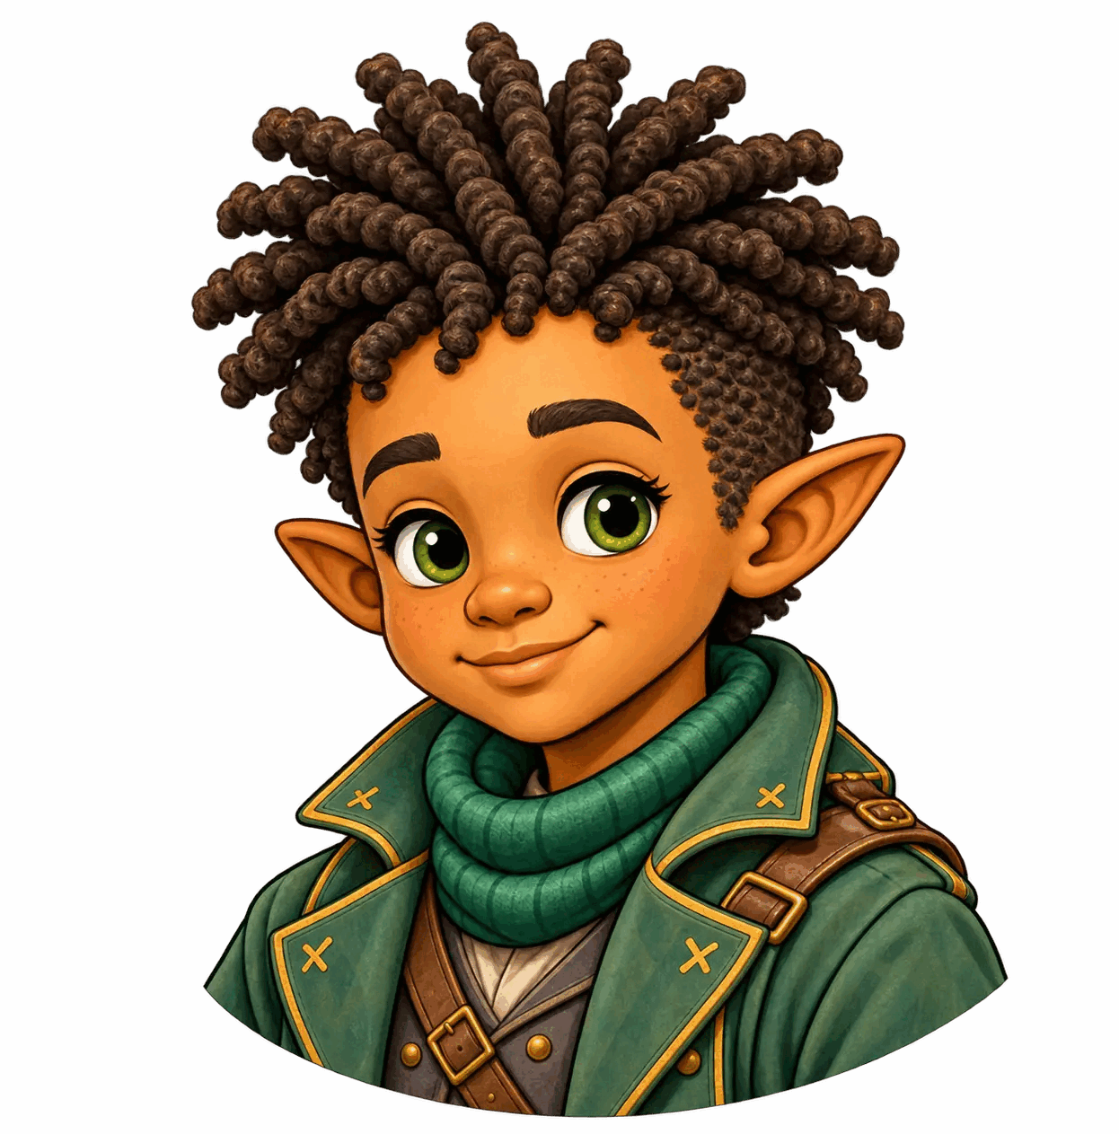 |  |  |  | 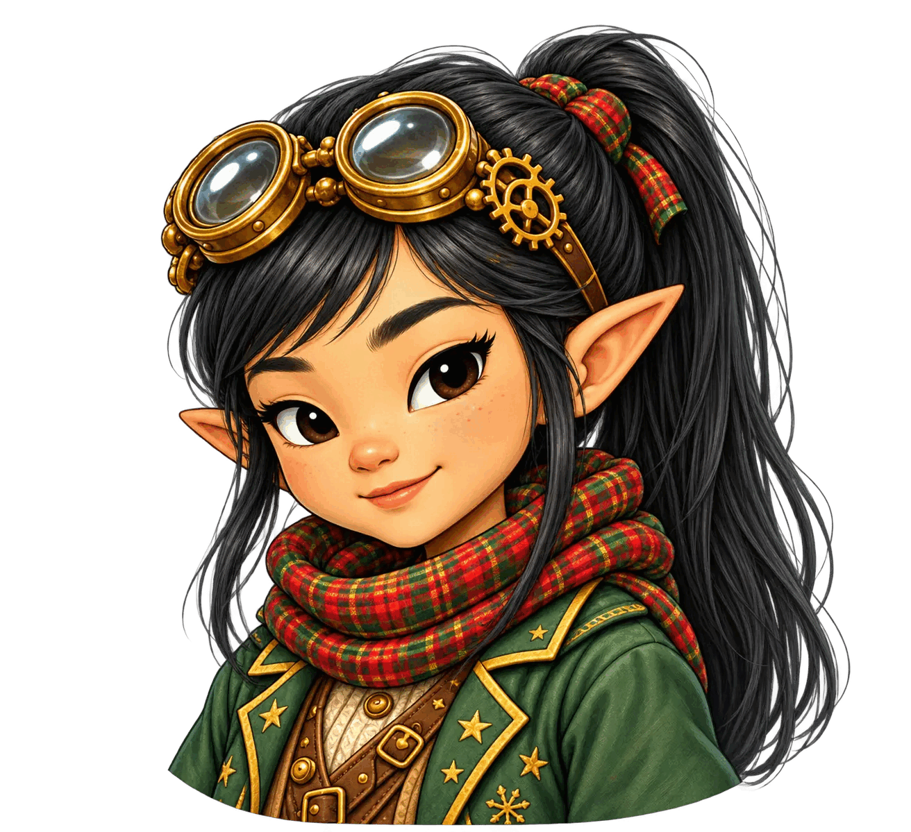
Keenan | Bella | Reso | Lola | Sela

