Dear [child’s name],
You made it to the Top of the Nice List!
We heard how [kind act your child did]. We also heard how much you practiced [activity or skill]. [Celebrate their effort or progress.] We are so proud of you.
Your kindness was noticed all the way at North Pole Academy.
We worked together to make a Christmas Eve surprise especially for you. There is just one little mystery: where is it hiding?
Follow the clue in your envelope to find out!
With love,
The Dream Team
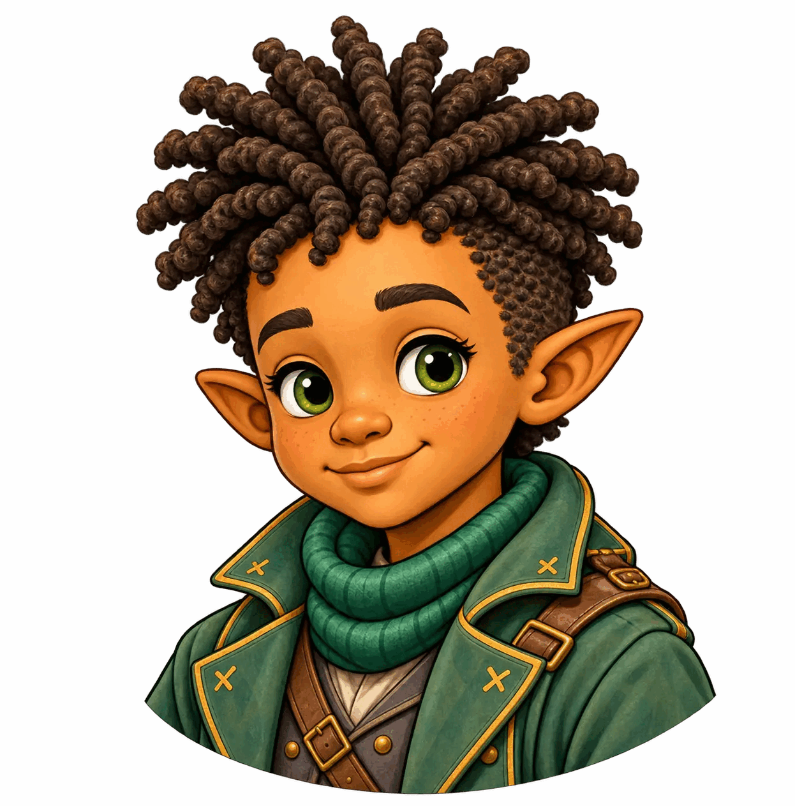 | 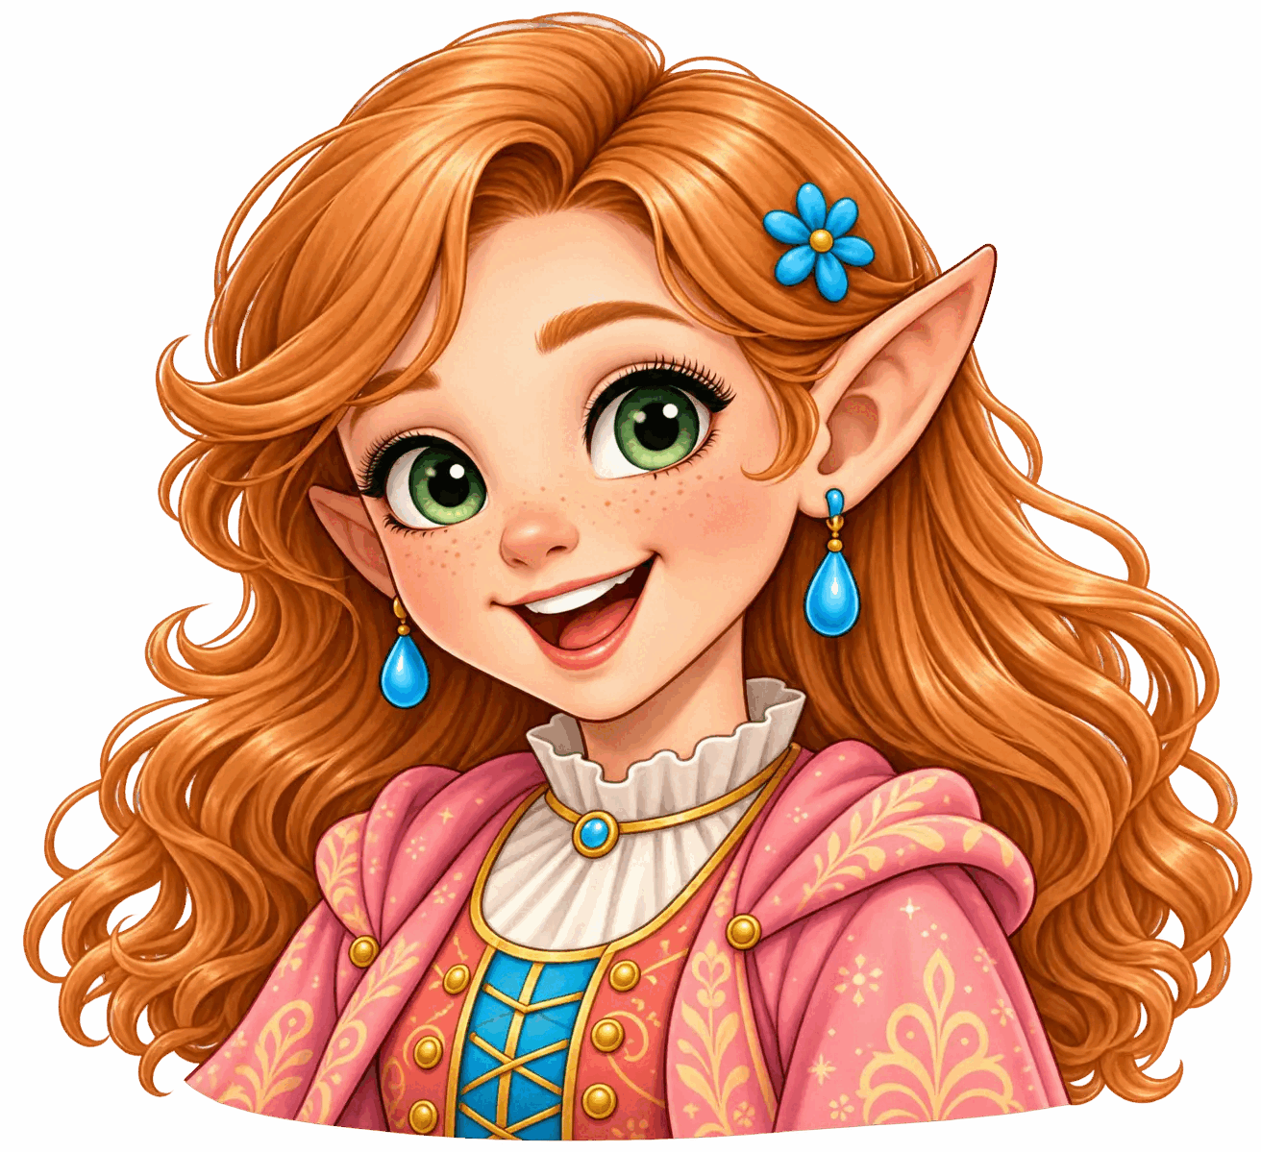 |  |  | 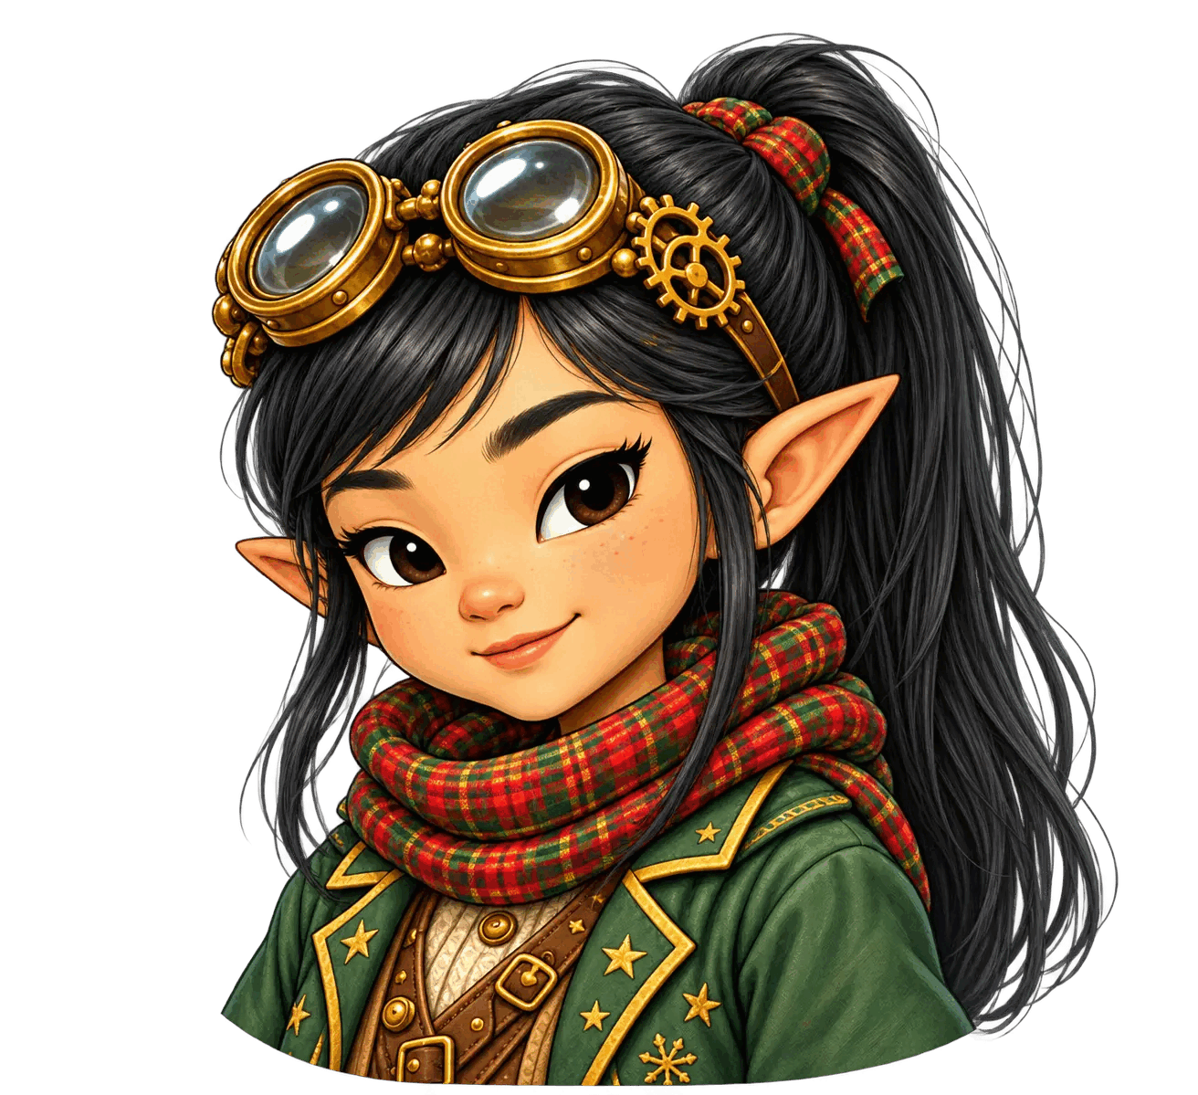
Keenan | Bella | Reso | Lola | Sela

