Dear [child’s name or children’s names],
Thank you for helping the Dash Crew!
I found the medallion you placed [with my cookies] and brought it safely back to the North Pole. The Dash Crew was very relieved and very proud that you answered Neva’s call for help.
You showed kindness, courage, and true North Pole Academy teamwork. Helpers like you make Christmas magic possible.
Merry Christmas, and thank you for taking such good care of the Dash Crew.
With gratitude,
Santa 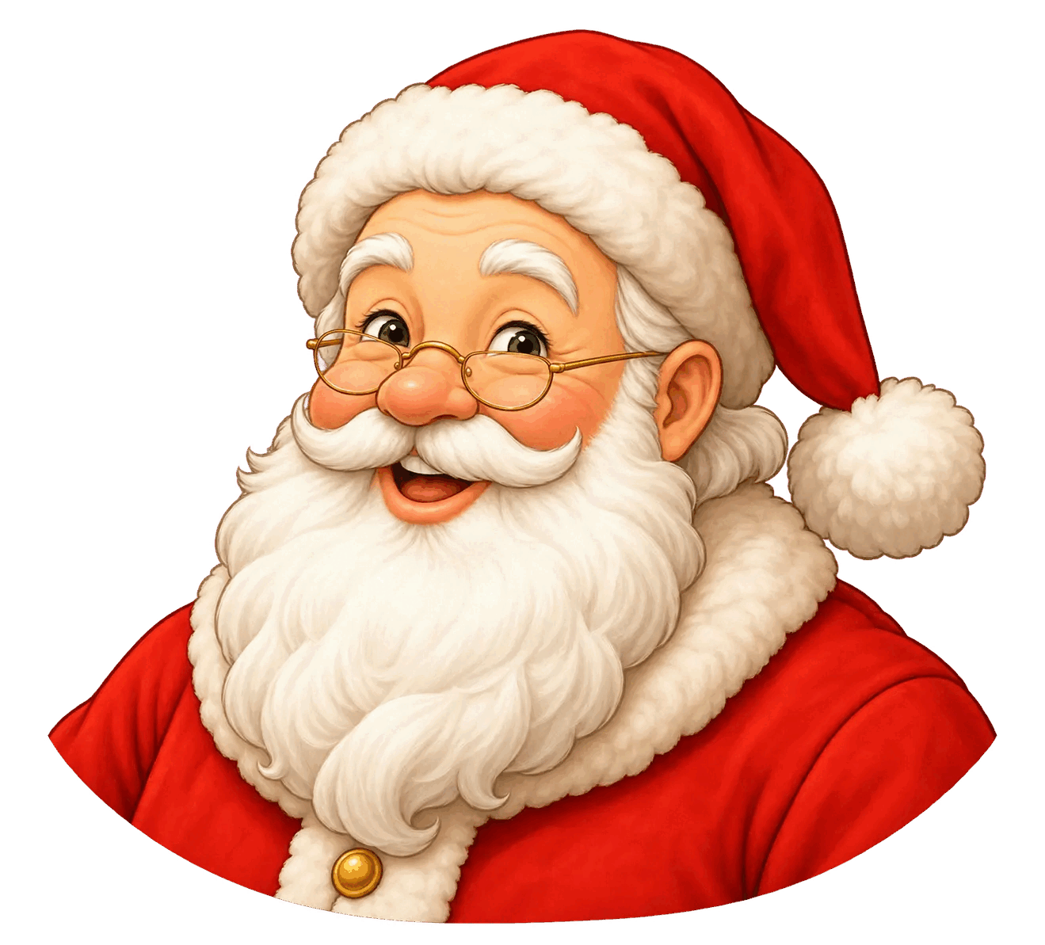
P.S. The [cookies] were delicious!

